Create Azure Resource Group
- Go to Google, enter Azure Portal Login in Search bar, and click Enter key.

- Click Resource groups to see Resource groups.
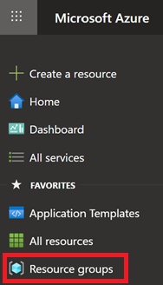
- Click Create button to create a Resource Group.

- Do the following to create Resource Group:
- Select Azure Subscription.
- Enter Resource group name.
- Select Resource Group deployment Region.
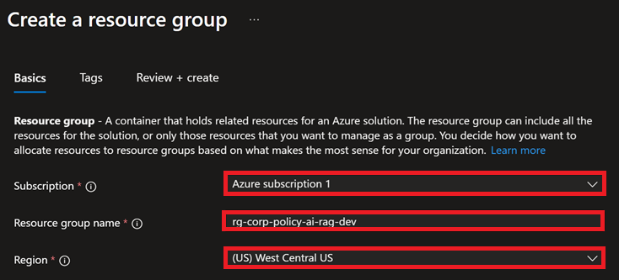
- Click Next button.

- Click Next button.
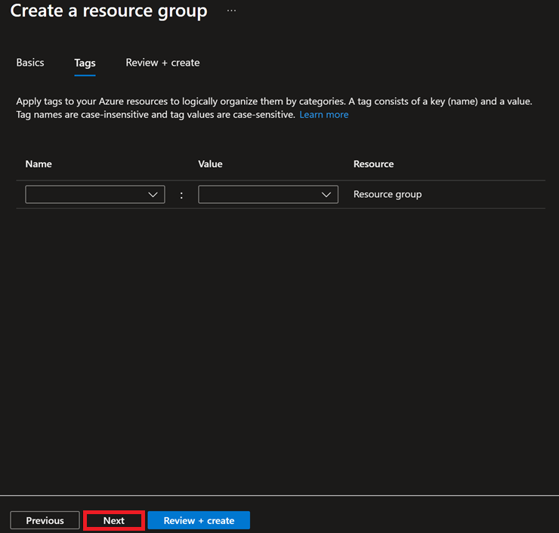
- Click Create button to create Resource Group.
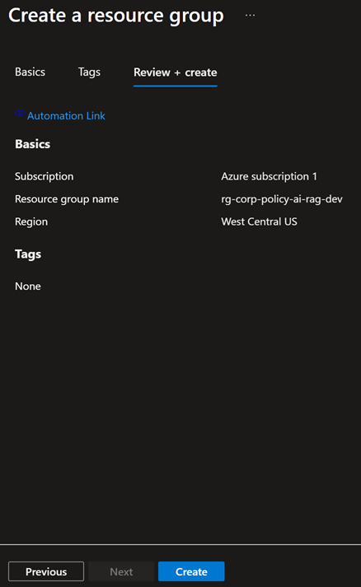
- Finished.

